Title:
Effects of short-interval disturbances continue to accumulate, overwhelming variability in local resilience [may revise]

Katherine Hayes¹, Brian Buma¹

Author Affiliations:
¹University of Colorado Denver, Department of Integrative Biology

* Correspondence to katherine.hayes@ucdenver.edu
Abstract: (322/300 words)
Increasing rates of short-interval disturbances have the potential to rapidly transform ecosystems via shifts in post-disturbance regeneration. While research has explored these compound events in multiple biomes, we know little regarding how local site conditions interact with short-interval disturbances to influence post-disturbance regeneration. Furthermore, little is known regarding the consequences of continued high frequency events – in other words, what happens when emerging new communities are themselves subject to short-interval disturbances? To investigate the effects of ongoing short-interval fires on regeneration, we examined post-fire forest regeneration in two locations in Interior Alaska. We established 50 plots across a mosaic of fire histories (1, 2 or 3 fires in <70 years) in an upland and lowland site in Interior Alaska. To investigate how shifts in community driven by short-interval fires differ according to local site conditions, we quantified abundance, proportion and density of conifer and deciduous regeneration in a drier upland site and a wetter lowland site. Both sites were dominated by black spruce prior to burning. In the drier upland site, black spruce (Picea mariana) presence declined sharply after two fires while paper birch (Betula neoalaskana) became increasingly abundant with each additional fire. In the wetter lowland site, less organic soil was consumed by fire and presence of black spruce persisted through an initial single reburn (two fires), indicating local topography may temporarily buffer the impact of reburning. However, after three burns, conifers were effectively eliminated in both upland and lowland stands. Continued reburning in deciduous stands promoted increasing dominance and shifts in deciduous species. Deciduous regeneration differed with site: birch dominated in upland plots while willow (Salix spp.) and aspen (Populus tremuloides) dominated in lowlands. Results of this study offer strong empirical evidence of the divergence of boreal successional trajectories from previous historic norms. More broadly, this demonstrates that shifts in postfire succession in forested ecosystems continue to accumulate with additional short-interval disturbance events, overwhelming the interactive effects of local site conditions.
Keywords: boreal, reburns, regime shifts, succession, fire frequency, ecosystem transformation

Introduction
Disturbances are a major driver of community composition and biomass, and in many regions are the major force that create and maintain ecosystems themselves (e.g., grassland vs. forests, Dantas et al. 2016). Theory suggests that in disturbance-adapted systems, communities can recover via resilience mechanisms after even intense disturbances (“ecological memory,” Johnstone et al. 2016). Here, resilience is defined as the degree of disturbance a system or community can absorb without undergoing meaningful transformational change (i.e., shifting into an alternate state) (Holling 1973, Picktett et al. 1989). In this context, if additional disturbance events occur within the timeframe of recovery, resilience mechanisms can be overwhelmed, enabling irreversible population collapse and subsequent “ecological surprises” (Paine et al. 1998): recovery trajectories not easily predictable from knowledge of the individual disturbance agents themselves (Scheffer and Carpenter 2003, Buma 2015). Examples abound, both terrestrial and aquatic – from changes in bamboo communities after fires and floods (Gagnon 2009), coral reef phase shifts after fishing and hurricanes (Hughes 1994), and experimental aquatic mesocosm studies (Kercher and Zedler 2004). If there is a long-term shift to different disturbance regimes (e.g., higher frequency) or other feedbacks, the new community types can persist, driving fundamental shifts in ecosystem structure (e.g., grazing and fires, Archibald et al. 2005; coral reef functioning, Jones et al. 2004). Theoretical modeling agrees, and further suggests changes in disturbance frequency are more important than changes to severity or other disturbance characteristics (Fraterrigo et al. 2020) in driving variability in recovery.
Research into the effects of disturbance frequency changes have almost exclusively focused on high severity disturbances and single short-interval events (two disturbances). This limits our understanding of the ongoing effects of continued short-interval disturbances. While modeling suggests progressive loss in ecosystem functions (e.g., ongoing fires in Yellowstone, Westerling et al. 2011), it is also true that subsequent disturbances interact with previous disturbance conditions, changing severity and overall impacts which can limit future disturbance severity or even occurrence (Parks et al. 2015, Buma et al. 2020). Trajectories inferred from single short-interval events may therefore not be valid if frequency of disturbances remains high. In addition, effects on ecosystems are mediated by external factors, such as topography and local site conditions. Theoretically, this should modulate cumulative impacts (Paine et al. 1998), though if frequency is truly the most significant factor (Fraterrigo et al. 2020) then that moderation effect should disappear with ongoing events. This too has not been empirically investigated.
This study tests theories of continued short-interval disturbance effects directly in a disturbance adapted biome by looking at 1, 2 or 3 events in short succession across two topographic contexts with known differences in resiliency. If changes continue to accrue with a continued high disturbance frequency, we should see ongoing divergence between each disturbance history; similarly, if frequency is the most important driver of ecosystem recovery trajectories, we should see resilience erode even in favored, historically more resilient/resistant to change topographic contexts.
We use fires and boreal forests as our test system. Fires are one of the most significant drivers of ecosystem change; on average 464 Mha burn each year (Randerson et al. 2012, Forkel et al. 2019), though the loss is not permanent if the forest recovers. Fire is the primary disturbance in boreal systems (Kurkowski et al. 2008), driving an overall loss in forest cover second only to deforestation in the tropics in terms of area (Hansen et al. 2013). Globally, there is a strong expectation for increased wildfires, and subsequent concern about ecosystem viability, in Europe, Africa, and North America (IPCC 2014).
Boreal forests are globally significant in terms of permafrost (Mann et al. 2012) and carbon stocks (Alexander et al. 2012) and are highly fire adapted and warming rapidly, meaning they are ideal to test theory related to changes in disturbance frequency, multiple disturbances, and ecosystem resilience. Boreal fire return intervals were historically >100 years in Interior Alaska (Yarie 1981, Viereck 1983, Johnstone et al. 2010). These forests are highly resilient to fire. The predominant post-fire successional pathway in boreal Interior Alaska is self-replacement (Kurkowski et al. 2008, Ott et al. 2006). Black spruce (Picea mariana) typically self-replaces within 5-10 years via a large canopy seedbank after fire (Greene et al. 2013, Kurkowski et al. 2008, Johnstone et al. 2004). When fires occur over very short intervals, however, that resilience mechanism can fail, leading to forest loss (Johnstone et al. 2010).The definition of short interval fires varies by study (e.g., 5 or 25 years, Buma et al. 2020, Fairman et al. 2019; 50 years McRae et al. 2006, 30 years Turner et al. 2019), but for the boreal forest can be functionally defined as when second (or third) fires occur prior to the time required to regenerate the local serotinous seedbanks, extirpating local populations and facilitating rapid forest type conversion (Buma et al. 2013, Enright et al. 2015). Here we investigate fire return intervals from 12 –30 years (see Methods, Table S1).
Loss of aerial seedbanks can favor wind-dispersed species with longer dispersal distances (e.g., 80m for black spruce vs. several kilometers for aspen or birch; McCaughey et al. 1985, Marquis et al. 1969, Burns and Honkala 1990), which can better colonize from outside burn perimeters (Brown and Johnstone 2012). Models suggest short-interval fires will lead to a shift in local community composition from conifer-dominated stands to deciduous forest (Mann et al. 2012, Roland et al. 2019, Rupp et al. 2002) or grassland (Brooks et al. 2004, Roland et al. 2013). Here, we define short interval fires in the boreal as <50 years given system-specific research that suggests 50 years or more are required for full aerial seedbank regeneration (Johnstone et al. 2004).
Under shortening fire intervals, black spruce self-replacement may be further disfavored by the interactive effect of soil consumption (a metric of burn severity) and deciduous seed characteristics (Brown and Johnstone 2012, Johnstone and Chapin 2006, Johnstone et al. 2009). Mature black spruce stands have deep soil organic layers, which strongly constrain regeneration of other species (Johnstone and Chapin 2006, Greene et al. 2007). Short-interval burns can consume deep soil organic layers entirely, negating the establishment advantage of black spruce seeds and favoring aspen (Populus tremuloides; Greene and Johnson 1999) and birch (Betula neoalaskana; Zasada 1971) which produce large quantities of small wind-borne seeds that germinate directly on mineral soil surfaces (Roland et al. 2013, Johnstone et al. 2010, Greene et al. 2007).
Ecosystem transitions (from black spruce to deciduous species) following two consecutive, short-interval fires have been well documented in Interior Alaska (Johnstone et al. 2004), the Yukon Territory (Brown et al. 2015, Whitman et al. 2018), Eastern Canada (Bergeron et al. 2012) and Northern Minnesota (Camill and Clark 2000, Frelich et al. 2017). However, the two key limitations mentioned above apply. First, we do not know if those emerging communities are themselves resilient to ongoing short-interval fires (in other words, what happens when a deciduous forest reburns within a short interval?). To our knowledge, there are no studies examining 3 burns in short succession, despite the fact that ongoing short-interval burning is the natural consequence of increasing fire frequency over all. Second, previous studies on short-interval fires are primarily in gently sloped upland environments (Gibson et al. 2016, Houle et al. 2017) where fires are generally high intensity, so the impact of short-interval fires in more inherently resilient topographic contexts is unknown. Higher soil moisture in lowland areas should make them more resilient to soil consumption. The under-examination of reburns in lowlands compared to uplands may be partially due to the historic unlikelihood of lowlands burning (Le Goff and Sirois 2004, Whitman et al. 2019, Alexander and Mack 2015), though they represent a substantial fraction of the biome (~42% in interior Alaska, Douglas et al. 2014).
This study characterizes post-fire regeneration of tree species in upland and lowland stands across a gradient of 0, 1, 2 or 3 fires since 1940 occurring via a rapid increase in fire frequency in boreal interior Alaska. Given the evidence that short interval fires can trigger ecosystem regime shifts from coniferous to deciduous systems (Johnstone et al. 2011, Brooks et al. 2004, Hoy et al. 2016), understanding the ongoing effects of multiple short-interval fires, especially in regenerating deciduous stands, is essential to understanding and predicting environmental and climatic change. We ask the following research questions: 1) what is the impact of ongoing short-interval reburning in boreal forests and 2) does local landscape position interact with continued reburning to influence the dynamics of conifer and deciduous regeneration? We hypothesize the following: initial short-interval fires will reduce conifer regeneration and favor deciduous regeneration in uplands, and repeat burning (3 fires in sequence in short intervals) will push historically-resilient lowland stands toward the same outcome. This hypothesis relies on the assumption that continued short-interval fires will erode the theorized resilience mechanism of wetter, poorly drained lowland topographies.

Methods

Site Selection
To investigate these questions, we worked in the boreal forest of interior Alaska. We established 50 20x20m plots in the summers of 2018 and 2019 between an upland and lowland location in Interior Alaska in pre-fire black spruce forest types (Fig. 1). Plots were randomly placed within described burn histories, an average of 4.7 km apart (minimum 90 meters, maximum 13 km, median 4.19 km) and a minimum of 100 meters away from unburned legacies to control for black spruce dispersal distances. Plots were stratified evenly between two topographic positions: an upland and lowland location. The upland site (n = 26) represents well-drained, gently sloped (slope 3-13 degrees) boreal forest topographies; the lowland (n = 24) a flatter (slope = 0.3-2.6 degrees) and more poorly drained environment (Fig. S1). Plots were climatically similar (Table S2; Western Regional Climate Center). Both are on the northern edge of the discontinuous permafrost zone and nearby unburned black spruce communities have shallow permafrost in both locations (data not shown).
Using historical aerial photographs, burn history (Alaska Large Fire Database, FRAMES, 2018), and modern remotely sensed fire perimeters (Monitoring Trends in Burn Severity database, MTBS), we identified pre-fire mature black spruce stands that experienced one to three severe (meaning complete aboveground mortality) fires in the last 60 years; all stands underwent the final burn in 2003-2006 (Table S1). Plots represented four specific reburn histories: 1) mature unburned black spruce forest stands (n = 8; Fig. 2A), 2) once-burned black spruce forest recovering from a single recent (>50 years) fire (n = 15, ~15-16 years ago, Fig. 2B), 3) twice-burned black spruce forest recovering from two short-interval fires (n = 15, one ~15-16 years ago, and the second ~30-50 years ago, Fig. 2C), and 4) thrice-burned black spruce forest (n = 12, burned once ~15-16 years ago, a second time ~30-50 years ago and finally a third ~45-70 years ago; Fig. 2D). For the earliest fires, pre-fire composition and complete aboveground mortality at a plot was inferred via the historical photographs and verified via wood anatomy/tree ages (to ensure no survivors from previous fires; data not shown). Fires were of comparable size (Table S1). All burned plots were sampled 15-16 years postfire.

Field Sampling
To determine the impact of repeat short-interval fires on conifer and deciduous post-fire regeneration, we surveyed density, basal area and species composition of tree species on each plot. We recorded species, diameter, and condition (live or dead) of all individuals above diameter at breast height (DBH; or 1.37 meters). Where density precluded counting over the entire 400 m², we counted within a randomly selected subset (100 or 200 m²) and scaled accordingly. We recorded presence, species and condition of seedlings that fell below 1.37 meters across ten 1-m² sections randomly placed on each plot. For asexual reproducers like willow and aspen, each individual stem in a given clump was counted; clumps and their characteristics (including basal area) were pooled and treated as individuals to avoid overestimating abundance of regeneration events. Trees and seedling counts were pooled in this study to focus on broad-scale trends in regeneration.
We calculated three metrics of regeneration: 1) density (number of stems per hectare), 2) basal area (square meters per hectare) and 3) the relative proportion of species present within a plot (presence/absence). The drivers and implications of changes in tree density, tree basal area and tree proportion are distinct and meaningful: stem density represents an important characteristic of post-fire stand structure, basal area indicates trends in overall biomass and tree size and the proportion of tree species present on a plot signals stand-level patterns in post-fire tree community composition.
To characterize soil characteristics across the burn histories, we evaluated organic layer depth and percent cover of exposed mineral soil. Organic layer depth was measured at the center and at each corner of each plot. Percent cover of organic and exposed mineral soil surfaces were estimated across 1-meter subplots at each corner of each site. To infer soil consumption in the most recent fire, distance from adventitious roots (opportunistic, lateral roots produced after initial root system development) to current soil surface was measured where snags with such roots were available to sample following the approach of Kasischke and Johnstone 2005 (data presented in supplement).

Data Analysis
To investigate the interactive effects of short-interval fires and landscape position on conifer and deciduous regeneration, we created a series of generalized linear models to model both density and basal area of conifer and deciduous regeneration. To investigate whether the effects of fire interacted with topographic position to influence regeneration, we used an interaction term between the two variables. We used negative binomial regression to model conifer and deciduous density, given its effectiveness in modeling overdispersed ecological count data. We used a gamma distribution to model basal area of deciduous species (conifer species had insufficient basal area present in reburned plots to model). To evaluate the role of specific topographic variables in influencing regeneration, we tested whether adding slope, elevation or annual solar radiation as covariates improved model using the cumulative impact of residual fit, root mean square error values and AIC values. A maximally complex model would include fire, topographic position, slope, elevation and solar radiation as fixed effects with an interaction term between fire and topographic position. At a minimum, models would include fire and topographic position and an interaction term between the two, indicating that fire and site location (upland vs lowland) explained the bulk of variation in regeneration. We evaluated the importance of each variable by comparing the cumulative evidence provided by effect sizes, standard errors and confidence intervals. Slope and solar radiation of each plot were calculated using IFSAR digital elevation models from the Alaska mapping initiative (USGS 2019, 5m). Elevation, while an important factor driving tree composition in Alaska, was not included as a variable since it did not vary meaningfully across plots (Fig. S1B).
All analysis, model fit, and selection were performed in R version 3.5.2 (R Core Team, 2018) and reported means include standard errors. All GLMs were built using the ‘MASS’ package (Venables and Ripley 202). Data and code used in analysis available at public repository: github.com/katerosehayes/tree-regen-manuscript. Because our plots are clustered by design to take advantage of natural experimental conditions, spatial autocorrelation among plots was assessed using Moran’s I (Moran 1950). We found evidence of spatial autocorrelation within tree data of lowland plots but accounted for autocorrelation by including topographic position as a random effect in LMEs (Table S3).

Results
Unburned plots were dominated by conifers, by design. Unburned upland plots had greater basal area (29.5 m²/ha, SE 2.7 m²/ha) and density of conifers (6,681 stems/ha, SE 2,676 stems/ha) on average compared to lowlands (16.6 m²/ha, SE 2.1 m²/ha) and (12,975 stems/ha, SE 5,113 stems/ha). Deciduous species were largely absent from unburned plots (Fig. 3).

Patterns in post-fire regeneration
Density of regeneration starts high but decreases increasingly quickly with each additional fire. In upland plots, conifer density increased 6.8x after one fire (relative to unburned plots) before decreasing by a factor of 3.7x after two fires (relative to the single burn plots) and 16.2x after three fires (relative to the twice burned plots). In lowlands, conifer density increased by a factor of 3.7x after one fire and continued to increase by a factor of 1.1 after the second, before declining by a factor of 32 after three fires.
Density of deciduous species increased by a factor of 62 after one fire in upland plots, and then declined slightly with each additional fire (Fig. 4). In lowland plots, deciduous density increased by a factor of 19.5 after one fire, and by a factor of 2.8 after two fires, indicating a slower trend (for numerical values, see Fig. 4).
Similar to density, conifer basal area declined after one fire in both sites, but the decline occurs differently between sites (Fig. 5). Upland conifer basal area declines by a factor of 512 while lowland conifer basal area declines by 9.5. A similar trend exists in deciduous basal area: after one fire, deciduous basal area increased by 5.25 in uplands but declines by 0.6 in lowlands (Fig. 5). [needs update please ignore]
All 1-3x burned plots were dominated in abundance by deciduous species, but the specific species present differed between upland and lowland sites (Fig. 6). Once-, twice- and thrice-burned lowland regeneration was predominantly willow (29.3%, 55%, and 58% respectively) with aspen emerging after the third burn (23.5%). Regeneration in burned upland plots differed across reburn sequence: willow presence declined across reburn while birch presence increased to 62.9% by three fires (Table S4).

Post-fire soil characteristics
Lowland organic-layers were thicker than upland layers regardless of number of reburns by a factor of 1.6, and the difference between the two topographic positions was largest in twice-burned plots where lowland organic-layers were larger by a factor of 3.2 (Fig. 7). The decline in organic layer depth occurs faster in upland plots than in lowland plots: organic layers were reduced by a factor of 3.2 after one fire in upland plots, but only by a factor of 1.8 in lowland plots (Fig. 7B). Similar trends exist in exposed mineral soil: upland plots had no exposed mineral soil in unburned plots but saw an increase in the amount of exposed mineral soil, up to 100% in some thrice-burned plots (Fig. 7C).
Interactive effects of fire and topographic position on conifer and deciduous regeneration
The effect of fire on regeneration varied between topographic position and between conifer and deciduous species. As expected, fire decreased density of conifer regeneration (-2.2, SE 0.34) (Table 1). Fire had a greater positive effect on deciduous basal area (1.57, SE 0.23) than deciduous density (0.3, SE 0.33) (Table 2).
The strength of the interactive effect between fire and topographic position differed according to the metric of regeneration. Fire interacted with topographic position strongly to influence conifer density (effect size 0.63, SE 0.45), while the effect of interaction between fire and topographic position on deciduous density appears smaller, given the relatively large standard error (0.35, SE 0.43).
Conifer density model fit improved when solar radiation was included as a fixed effect, while deciduous density was best explained by adding slope and solar radiation as fixed effects and basal area was best modeled by including slope as a fixed effect (Table SX).

Discussion
Using novel empirical evidence of 3 fires in short sequence, we show that reburning-triggered shifts in forest composition and structure continue beyond two fires and that new effects begin to emerge with three short-interval fires. Our results suggest that the transition from conifer to deciduous species documented by Johnstone et al. XX and others continues to occur with additional fires in sequence. Furthermore, specific species composition within deciduous trajectories differed between topographic position, indicating the importance of local topography in filtering specific successional outcomes. Our results suggest topographic position can interact with reburning to alter post-fire trajectories but also that 3 reburns in sequence has led to a disruption of self-replacement trajectories occurring even in a historically resilient topographical context.
Conifer regeneration declined with reburning in favor of deciduous species. These results are consistent with trends reported in Johnstone et al. 2014 and others, who have documented a sharp decline in conifer regeneration following two fires in short sequence. However, the extent of conifer population collapse documented in this study surpasses that reported in Johnstone et al. 2014 and others: Johnstone et al. 2014 reported that …. .
Previous studies documented this regime shift resulting from two fires, and we confirm that here, however they stop at 2 fires and cannot address the question of ongoing burning – here we find that not only doe sthe ecosystem continue to change, but at a rapid pace… from a 6x reduction in conifers to a 32x after a subsequent event…
Furthermore, our finding that conifer populations declined later in reburn sequence in the lowland site suggests that local topographical context may allow conifers to persist for longer under repeated short-interval fires. Three reburns appear move the lowland landscape across what may be a critical threshold from a small but persistent conifer population to a locally extirpated conifer presence, similar to upland counterparts.
Post-fire soil characteristics differed between topographic contexts as hypothesized: uplands had substantially thinner organic layers and more exposed mineral soil than lowlands, but organic layer thickness decreased with greater burn frequency in both locations. Given the well-documented role of burn severity in altering competitive dynamics between coniferous and deciduous species in the North American boreal (Johnstone and Chapin 2006, Whitman et al. 2018), this variation between topographic position indicates that black spruce may retain competitive advantage longer in lowlands under single fires or reburn events. However, lowland plots still underwent a transition to deciduous communities linked with a removal of organic layers, indicating potential resilience via initially lower soil consumption (implying lower fire intensity) is limited and that, as predicted by theory, frequency of events is as important as any disturbance characteristic in driving recovery trajectories (Fraterrigo 2020).
Post-fire stand characteristics differed across reburn sequence and between topographic position. Tree density and basal area were consistently higher in upland stands than lowland counterparts. Greater exposed mineral soil lead to greater deciduous basal area but reduced deciduous densities, indicating a more open stand structure with larger individual trees. A shift in stand structure (via changes to stand density) may alter landscape characteristics like aboveground carbon storage and landscape flammability. Given that fuel will play a central role in ongoing boreal fire regime change, understanding the influence of altered stand structure on local fuel loads and structure will be crucial to managing and predicting future fire behavior (Higuera et al. 2008).
Species-specific trends in presence/absence, density and abundance differed between upland and lowland sites: upland reburned plots were composed of willow and birch in higher abundance and densities than comparable lowland plots and experienced a decline in black spruce earlier in the reburn sequence. Black spruce populations declined slower in lowland plots and were replaced by aspen and willow after three fires. This divergence suggests that both site-level differences in drainage conditions and reburning effects play an important initial role in determining species-specific successional outcomes in boreal forests – but that the effects of reburning continue to accrue after the 2nd event.
These results are limited in spatial and temporal scale in two major ways: one, our assessment of forest regeneration occurs 15-16 years post-fire, resting on the assumption that early recruitment dynamics in boreal Alaskan forests remain sufficiently predictive of future composition. The eventual composition of these specific sites will remain to be seen, though the bulk of evidence provided by Johnstone and Chapin 2006 and others indicate that early patterns of regeneration in the boreal tend to be highly prescriptive of multidecadal successional trajectories. Furthermore, the spatial extent of larger ecosystem transition in the boreal remains unknown: emerging deciduous communities appear to be spatially constrained within fire or reburn perimeters (Roland et al. 2019). The results of this study are similarly limited in scale. However, we contribute to the growing body of evidence of site-level successional trajectory disruption via short-interval reburns.
Our work presents several key inferences relevant to boreal forest ecology and disturbance theory generally. First, low quantities of black spruce seedlings in twice- and thrice-burned plots suggests a potential local extirpation of black spruce seed sources, preventing future self-replacement. Second, organic soil layers in both sites were consumed during each reburn, even in the wetter lowland site, leading to increased exposure of mineral soil surfaces. Organic layers in both locations have not recovered to inferred pre-fire depth, even 15 years post-fire. Finally, deciduous communities emerged in both upland and lowland sites, replacing original black spruce communities entirely. Together, these patterns suggest that short interval fires lead to meaningful disruption of existing successional trends despite proposed local resiliency within poorly drained lowland conditions, and that repeat burning in emerging deciduous post-fire communities not only can occur but continues to drive community shifts towards dominance of deciduous trees and shrubs partly facilitated by removal of organic soil layers and surfaces. Results from this study have broad implications for transitions and trajectories of both coniferous and deciduous boreal forests under climate change, as it appears the widely anticipated reduction in fire return intervals will continue to change forest structure and function beyond initial short-interval effects and regardless of initial local resiliency.

Conclusions
The effects of more frequent disturbances do not stop with the first ecosystem transition, recovering communities themselves can be transformed by ongoing short-interval events. Further, high frequency disturbances can drive transitions even if those occur with lower intensity. For boreal forests, successional trajectories can quickly become untethered from regional legacy conditions. Ongoing transformations are more in line with primary successional pathways then secondary, and while wetter lowland forests are initially more resistant to ecosystem transitions, that resilience is overcome by subsequent fires. The unique perspective of this study demonstrates current shifts in disturbance regimes continue to drive quantitatively different outcomes compared to single, short-interval events, and therefore questions regarding resilience to future climate effects must explicitly consider unfolding, emerging, and ongoing changes, not just snapshots in time.

Acknowledgements
This research was supported by funding provided by the National Science Foundation (NSF-OPP-1903231). We thank Kristin Olson, Vishnusai Kodicherla, Kyle Martini and Kyle Turchick for assistance in the field and to Shelby Weiss, Adrienne Marshall, and Jason Shabaga for valuable support and advice. We thank Melissa Lucash and Kathy Kelsey for providing friendly review which significantly contributed to the quality of the paper.

Literature Cited
Alaska Large Fire Database, Alaska Fire Service, Fire Research and Management Exchange System. 2018. Web. March 2018. https://www.frames.gov/catalog/10465
Alexander, Heather D., and Michelle C. Mack. 2016. A canopy shift in interior Alaskan boreal forests: consequences for above-and belowground carbon and nitrogen pools during post-fire succession. Ecosystems 19.1: 98-114.
Archibald, Sally., et al. 2005. Shaping the landscape: fire-grazer interactions in an African savanna. Ecological Applications 15(1):96–109.
Bergeron, Yves, and Nicole J. Fenton. 2012. Boreal forests of eastern Canada revisited: old growth, nonfire disturbances, forest succession, and biodiversity. Botany 90.6: 509-523.
Brooks, Matthew L., et al. 2004. Effects of invasive alien plants on fire regimes. BioScience 54: 677-688.
Brown, Carissa D., et al. 2015. Disentangling legacy effects from environmental filters of postfire assembly of boreal tree assemblages. Ecology 96: 3023-3032.
Brown, Carissa D., and Jill F. Johnstone. 2012. Once burned, twice shy: Repeat fires reduce seed availability and alter substrate constraints on Picea mariana regeneration. Forest Ecology and Management 266: 34-41.
Buma, Brian, et al. 2013. The impacts of changing disturbance regimes on serotinous plant populations and communities. BioScience 63(11): 866-876.
Buma, Brian, et al. 2020. Wildland fire reburning trends across the US West suggest only short-term negative feedback and differing climatic effects. Environmental Research Letters, 15(3), p.034026.
Buma, Brian. 2015. Disturbance interactions: characterization, prediction, and the potential for cascading effects. Ecosphere 6(4): 1-15.
Burns, Russell M., and Barbara H. Honkala. "tech. coords. 1990. Silvics of North America: 1. Conifers; 2. Hardwoods. Agricultural Handbook 654." US Department of Agriculture, Forest Service. Washington DC 2: 877.
Camill, Philip, and James S. Clark. 2000. Long-term perspectives on lagged ecosystem responses to climate change: permafrost in boreal peatlands and the grassland/woodland boundary. Ecosystems 3(6): 534-544.
Curtis, Philip G., et al. 2018. Classifying drivers of global forest loss. Science 361(6407): 1108-1111.
Dantas, Vinícius de L., et al. 2016. Disturbance maintains alternative biome states. Ecology Letters 19(1): 12-19.
Dinno, Alexis. 2015. Nonparametric pairwise multiple comparisons in independent groups using Dunn's test. The Stata Journal 15(1): 292-300.
Douglas, Thomas, et al. 2014. Sources and sinks of carbon in boreal ecosystems of interior Alaska: A review. Elem Sci Anth 2.
Enright, Neal J., et al. 2015. Interval squeeze: altered fire regimes and demographic responses interact to threaten woody species persistence as climate changes. Frontiers in Ecology and the Environment 13(5): 265-272.
Fraterrigo, Jennifer M., et al. 2020. Stochastic disturbance regimes alter patterns of ecosystem variability and recovery. PloS one 15(3): e0229927.
Forkel, Matthias, et al. 2019. Emergent relationships with respect to burned area in global satellite observations and fire-enabled vegetation models. Biogeosciences. 16: 57–76.
Frelich, Lee E., Peter B. Reich, and David W. Peterson. 2017. The changing role of fire in mediating the relationships among oaks, grasslands, mesic temperate forests, and boreal forests in the Lake States. Journal of Sustainable Forestry 36(5): 421-432.
Gagnon, Paul R. 2009. Fire in floodplain forests in the southeastern USA: insights from disturbance ecology of native bamboo. Wetlands 29(2):520–526.
Gibson, Carolyn M., et al. 2016. Variation in plant community composition and vegetation carbon pools a decade following a severe fire season in interior Alaska. Journal of vegetation science 27(6): 1187-1197.
Greene, David. F., and Edward. A. Johnson. 1999. Modelling recruitment of Populus tremuloides, Pinus banksiana, and Picea mariana following fire in the mixedwood boreal forest. Canadian Journal of Forest Research 29(4): 462-473.
Greene, David F., et al. 2007. The reduction of organic-layer depth by wildfire in the North American boreal forest and its effect on tree recruitment by seed. Canadian Journal of Forest Research 37(6): 1012-1023.
Greene, D.F., Splawinski, T.B., Gauthier, S. and Bergeron, Y., 2013. Seed abscission schedules and the timing of post-fire salvage of Picea mariana and Pinus banksiana. Forest ecology and management, 303, pp.20-24.
Hansen, Matthew C., et al. 2013. High-resolution global maps of 21st-century forest cover change. Science 342(6160): 850-853.
Higuera, Phillip E., et al. 2008. Frequent fires in ancient shrub tundra: implications of paleorecords for arctic environmental change. PloS one, 3(3), p.e0001744.
Houle, Gregory P., et al. 2017. Recovery of carbon pools a decade after wildfire in black spruce forests of interior Alaska: effects of soil texture and landscape position. Canadian Journal of Forest Research 48(1): 1-10.
Hoy, Elizabeth E., Merritt R. Turetsky, and Eric S. Kasischke. 2016. More frequent burning increases vulnerability of Alaskan boreal black spruce forests. Environmental Research Letters 11(9): 095001.
IPCC. 2014: Summary for policymakers. In: Climate Change 2014: Impacts, Adaptation, and Vulnerability. Part A: Global and Sectoral Aspects. Contribution of Working Group II to the Fifth Assessment Report of the Intergovernmental Panel on Climate Change [Field, C.B., et al. (eds.)]. Cambridge University Press, Cambridge, United Kingdom and New York, NY, USA, pp. 1-32.
Johnstone, Jill F., and F. S. Chapin. 2006. Effects of soil burn severity on post-fire tree recruitment in boreal forest. Ecosystems 9.1: 14-31.
Johnstone, Jill F., et al. 2004. Decadal observations of tree regeneration following fire in boreal forests. Canadian Journal of Forest Research 34(2): 267-273.
Johnstone, Jill F., et al. 2010. Changes in fire regime break the legacy lock on successional trajectories in Alaskan boreal forest. Global Change Biology 16(4): 1281-1295.
Johnstone, Jill, et al. 2009. Postfire seed rain of black spruce, a semiserotinous conifer, in forests of interior Alaska. Canadian Journal of Forest Research 39(8): 1575-1588.
Johnstone, Jill, et al. 2011. Modeling impacts of fire severity on successional trajectories and future fire behavior in Alaskan boreal forests. Landscape Ecology, 26(4):487-500.
Johnstone, Jill F., et al. 2016. Changing disturbance regimes, ecological memory, and forest resilience. Frontiers in Ecology and the Environment 14(7): 369-378.
Jones, GP., McCormick MI, M. Srinivasan, and J. V. Eagle. (2004) Coral decline threatens fish biodiversity in marine reserves. PNAS 101(21):8251–8253.
Kasischke, E. S., and Johnstone, J. F. 2005. Variation in postfire organic layer thickness in a black spruce forest complex in interior Alaska and its effects on soil temperature and moisture. Canadian Journal of Forest Research, 35(9), 2164-2177.
Kercher, S. M., and J. B. Zedler. 2004. Multiple disturbances accelerate invasion of reed canary
grass in a mesocosm study. Oecologia 138:455–464.
Kurkowski, Thomas A., et al. 2008. Relative importance of different secondary successional pathways in an Alaskan boreal forest. Canadian Journal of Forest Research, 38(7), pp.1911-1923.
Goff, Héloïse Le, and Luc Sirois. 2004. Black spruce and jack pine dynamics simulated under varying fire cycles in the northern boreal forest of Quebec, Canada. Canadian Journal of Forest Research 34(12): 2399-2409.
Hughes T.P. 1994. Catastrophes, phase shifts, and large-scale degradation of a Caribbean coral reef. Science 265(5178):1547–1551.
Mann, Daniel H., et al. 2012. Is Alaska’s boreal forest now crossing a major ecological threshold?. Arctic, Antarctic, and Alpine Research 44(3): 319-331.
Marquis, D. A., Solomon, D. S., & Bjorkbom, J. C. 1969. A silvicultural guide for paper birch in the Northeast. US Department of Agriculture, Forest Service, Northeastern Forest Experiment Station.
McCaughey, Ward W., Wyman C. Schmidt, and Raymond C. Shearer. 1985. Seed-dispersal characteristics of conifers in the inland mountain west. GTR-INT-203
Moran, P. A. 1950. Notes on continuous stochastic phenomena. Biometrika, 37(1/2), 17-23.
MTBS Data Access: Fire Level Geospatial Data. 2017. MTBS Project (USDA Forest Service/U.S. Geological Survey). http://mtbs.gov
Ott, L. et al. 2006. Successional processes in the Alaskan boreal forest. Alaska’s changing boreal forest. FS Chapin III, Ed. Chapter 7, pg 100.
Paine, RT., Tegner MJ, and Edward A. Johnson. 1998. Compounded perturbations yield ecological surprises. Ecosystems 1(6): 535-545.
Parks, Sean A., et al. 2015. Wildland fire as a self‐regulating mechanism: the role of previous burns and weather in limiting fire progression. Ecological Applications 25(6): 1478-1492.
Randerson, J.T., et al. 2012. Global burned area and biomass burning emissions from small fires. Journal of Geophysical Research: Biogeosciences, 117(G4).
Roland, CA., JH Schmidt, and EF Nicklen. 2013. Landscape‐scale patterns in tree occupancy and abundance in subarctic Alaska. Ecological Monographs 83(1): 19-48.
Roland, CA., et al. 2019. Regional variation in interior Alaskan boreal forests is driven by fire disturbance, topography, and climate. Ecological Monographs e01369.
Rupp, TS, et al. 2002. Modeling the impact of black spruce on the fire regime of Alaskan boreal forest. Climatic Change 55(1-2): 213-233.
Scheffer, M, and SR Carpenter. 2003. Catastrophic regime shifts in ecosystems: linking theory to observation. Trends in ecology & evolution 18(12): 648-656.
USGS National Geospatial Program. Interferometric Synthetic Aperture Radar (IFSAR) Alaska. DEM. Accessed November. 2018. https://catalog.data.gov/dataset/interferometric-synthetic-aperture-radar-ifsar-alaska.
Viereck, LA. 1983. The effects of fire in black spruce ecosystems of Alaska and northern Canada. The role of fire in northern circumpolar ecosystems, Wiley, New York, USA. 210-220.
Western Regional Climate Center, 2020. Web. 22 March 2020. https://wrcc.dri.edu/wraws/akF.html
Westerling, AL., et al. 2011. Continued warming could transform Greater Yellowstone fire regimes by mid-21st century. Proceedings of the National Academy of Sciences 108(32): 13165-13170.
Whitman, E, et al. 2018. Topoedaphic and forest controls on post-fire vegetation assemblies are modified by fire history and burn severity in the Northwestern Canadian Boreal Forest. Forests 9(3): 151.
Whitman, E, et al. 2019. Short-interval wildfire and drought overwhelm boreal forest resilience. Scientific Reports 9(1): 1-12.
Yarie, J. 1981. Forest fire cycles and life tables: a case study from interior Alaska. Canadian Journal of Forest Research 11(3): 554-562.
Zasada, JC. 1971. Natural regeneration of interior Alaska forests-seed, seedbed, and vegetative reproduction considerations. Proceedings, fire in the northern environment. USDA Forest Service, Pacific Northwest Forest Range Experimental Station, Portland, OR: 231-246.
Table 1. Parameters of negative binomial generalized linar models of regeneration density (stems/ha) as modeled by the best-performing combination of fire, topographic position and topographic attributes (slope or solar radiation).“Position” refers to topographic position.

Metric | Division | Effect | Coeff. | SE | 95% CI | z | df | p
Density | Conifer | Intercept | 75.99 | 36.9 | (-4.4, 153) | 2.06 | 37 | 0.05
Density | Conifer | Fire | -2.5 | 0.34 | (-2.89, -1.47) | -6.47 |  | <.01
Density | Conifer | Position | 1.58 | 1.24 | (-1.5, 4.62) | 1.27 |  | 0.2
Density | Conifer | Solar Radiation | -.0001 | 6.16e-5 | (0.0, 0.0) | -1.68 |  | 0.09
Density | Conifer | Fire * Position | 0.63 | 0.345 | (0.52, 1.85) | 1.39 |  | 0.165
Density | Decid. | Intercept | 200 | 33.67 | (-175.8, 1391) | 5.95 | 36 | <.001
Density | Decid. | Fire | 0.07 | 0.32 | (-0.69, 0.72) | 0.22 |  | 0.83
Density | Decid. | Position | 2.68 | 1.05 | (-2.63, 5.03) | 2.56 |  | 0.01
Density | Decid. | Slope | -0.08 | 0.09 | (-0.82, 0.18) | -0.84 |  | 0.401
Density | Decid. | Solar | 0.0003 | 0.00005 | (-0.00, -0.00) | -5.59 |  | <.001
Density | Decid. | Fire * Position | 0.41 | 0.42 | (-0.5, 1.37) | 1 |  | 0.32

Table 1. Parameters of gamma generalized linear models of regeneration basal area (m²/ha) as modeled by fire, topographic position and slope with an interaction term between fire and topographic position.“Position” refers to topographic position.

Metric | Division | Effect | Coeff. | SE | 95% CI | t | df | p
Basal  Area | Decid. | Intercept | -1.95 | 0.45 | (-2.86, -1.00) | -4.32 | 37 | <.001
Basal  Area | Decid. | Fire | 1.57 | 0.22 | (1.06, 2.05) | 6.96 |  | <.001
Basal  Area | Decid. | Position | -1.09 | 0.66 | (-2.33, 0.2) | -1.64 |  | 0.11
Basal  Area | Decid. | Slope | -0.13 | 0.06 | (-0.26, 0.00) | -2.23 |  | 0.03
Basal  Area | Decid. | Fire * Position | -0.48 | 0.33 | (-1.12, 0.18) | -1.46 |  | 0.15

Figure 1. Sampled wildfires and field site locations within Interior Alaska. Fire perimeters displayed in color and marked with year of fire. Highways marked with black line (Dalton highway in the Upland site, Steese Highway in the Lowland). Coordinates included are approximate.
Figure 2. Pictures of study sites. A) Unburned mature black spruce stand. B) Once-burned former black spruce stand, 15 years since last fire C) Twice-burned former black spruce stand, 15 years since last fire. D) Thrice-burned former black spruce stand, 16 years since last fire. Labels on the image describe years of fire and number of plots investigated. A-C from the upland site; D from the lowland.
Figure 3. Density (stems/ha) and basal area (m²/ha) of unburned reference plots in upland and lowland site. Plot A shows the distribution of basal area of conifer and deciduous species in unburned upland and lowland plots. Plot B shows the range of density of deciduous and conifer individuals in unburned upland and lowland plots.
Figure 4. Conifer and deciduous tree density (stems/ha) across reburn sequence and between upland and lowland sites. Conifer outliers above 30 stems/ha and deciduous outliers above 3000 stems/ha removed to improve visibility.
Figure 5. Total conifer and deciduous basal area (m²/ha) across reburn sequence and between upland and lowland sites. 2 outliers removed above 0.35 m²/ha for visual clarity.
Figure 6. Proportion of species-specific regeneration present on a plot (stems of a species divided by total stems) across reburn sequence between upland and lowland plots. A) Species-specific regeneration in Upland plots across reburn history. B) Species-specific regeneration in Lowland plots across reburn history. Error bars represent standard deviations and center points represent mean within reburn history and site. Data presented in Table 34.
Figure 7. Soil characteristics in upland and lowland plots. A) Depth of organic layer (cm) in upland and lowland plots according to reburn sequence. B) Percent cover of exposed mineral soil in upland and lowland plots across reburn sequence.
Figure 1
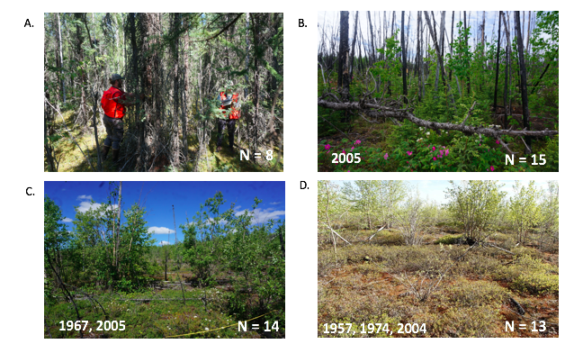
Figure 2
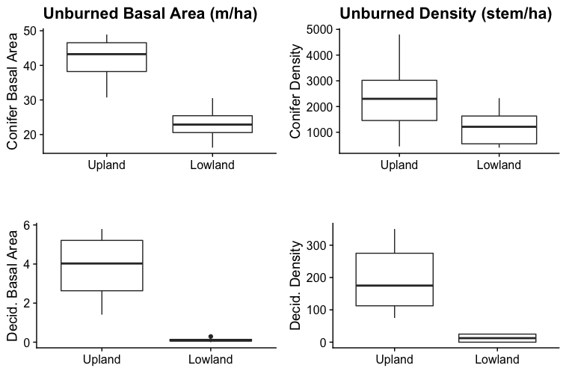
Figure 3 [still needs updating]
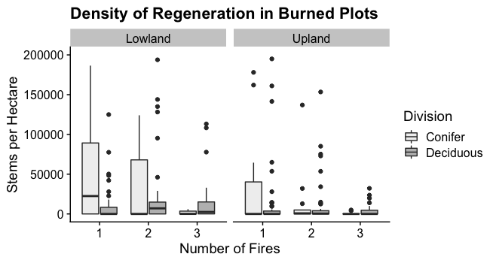
Figure 4
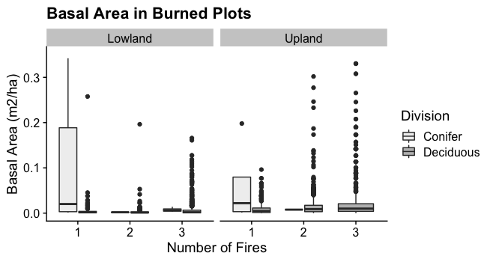Figure 5
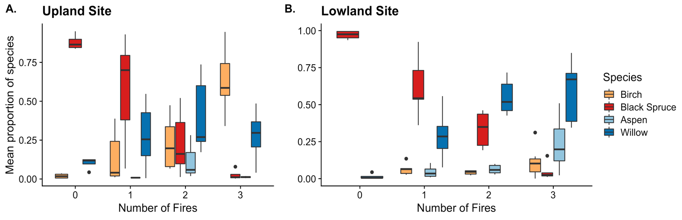
Figure 6
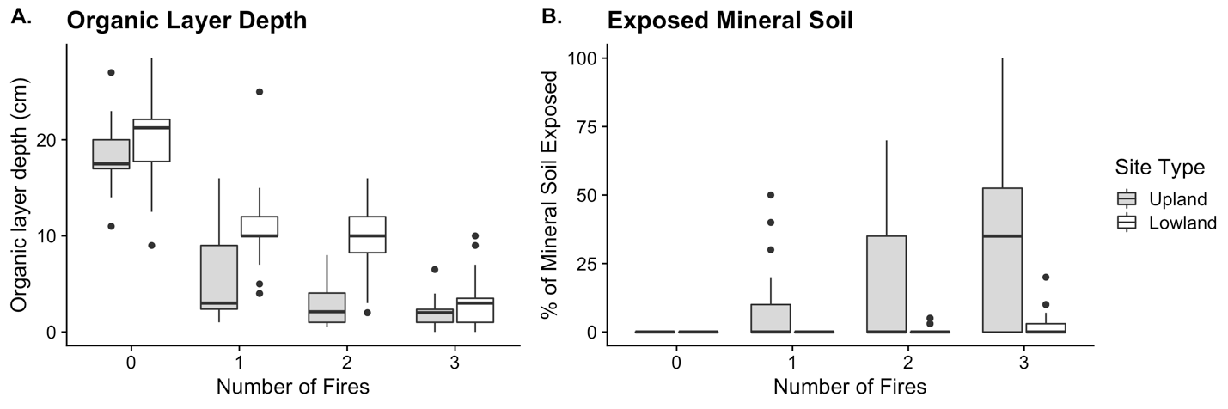
Figure 7

